SLIEVE RUSSELL HOTEL, GOLF & COUNTRY CLUB
Cranaghan, Ballyconnell, Co Cavan H14F306

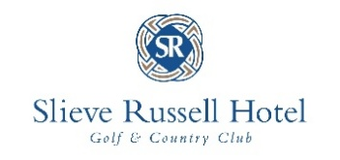
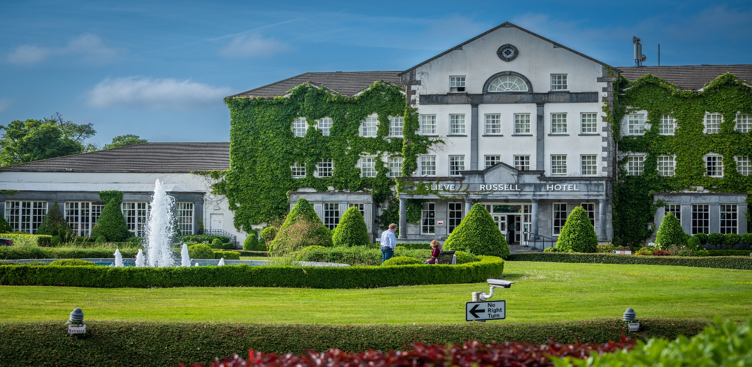

We are proud to be Ireland's First Dementia-Friendly Hotel

Visitor Access Guide
Contents
A Warm Welcome! 3
Contact Information 4
Getting Here 4
By Car 4
By Bus 5
Accessible Taxi Services 5
By Air 5
By Ferry 5
Your Journey through Slieve Russell 6
Making a Reservation 6
Emergency Evacuation 6
Guide & Assistance Dogs 6
Quiet & Sensory Spaces 6
Wheelchair Assistance & Charging 7
Accessible Bathrooms 7
Building Entrance 7
Lift Access 8
Bathroom Facilities 9
Guests with Visual Impairments 9
Cranaghan Way Walkway 9
Rushen Brook Garden (Secret Garden) 9
Adventure Golf 9
Dining & Leisure Accessibility 10
Our Restaurants 10
The Country Club 10
The Ciúin Spa 10
Smoking Area 11
Wheelchair Accessible Bedrooms & Bathrooms 11
Room 601 11
Room 603 11
Additional Information 12
Dementia-Friendly Bedrooms & Bathrooms 14
Features & Facilities 14
Sensory Story 16
Neurodivergent Friendly Sensory Story 16
Dementia Friendly Sensory Story 16
Emergency and Medical Information 16
Destination Highlights 17
Testimonials 18
James – July 2025 18
Margaret – July 2025 18
William – September 2025 18
Moya – June 2025 18
Gallery of Images 19

A Warm Welcome! ___________________________________________

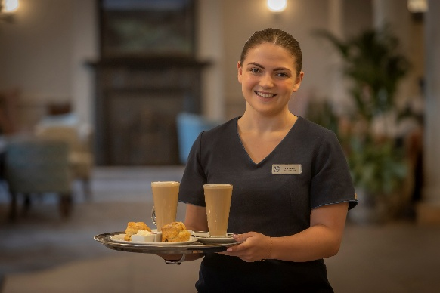

At the Slieve Russell Hotel, Golf, Spa & Country Club, we are dedicated to providing the warmest welcome to all our Guests. Your needs are our priority, and we are committed to excellence, innovation, and inclusion.
This Access Welcome Guide is designed to give you the confidence to enjoy your stay with us and explore Ireland's Hidden Heartlands. Our goal is for every Guest to feel at home, know they can ask for support, and enjoy the benefits of a well-earned rest. We aim to make every aspect of your stay comfortable, memorable, and enjoyable.
We also want to share the best local attractions and activities, so you can make the most of your time in our area.
Our dedicated team is renowned for friendliness and going the extra mile. We are proud to be Ireland’s first Dementia-Friendly Hotel and are committed to making our hotel accessible to a wide range of visitors.
We hope this guide provides all the information you need for a confident and enjoyable stay. If you have any specific requirements not covered here, please contact us:

📞 Phone: +353 (49) 952 6444
✉️ Email: enquiries@slieverussell.ie

We look forward to welcoming you!

Contact Information

To speak with a member of our team, please get in touch via telephone or email. We’ll be happy to assist you.
Telephone: +353 (49) 952 6444
Email: enquiries@slieverussell.ie

Getting Here

By Car
- If you are arriving by car and using a Sat Nav, our Eircode is H14 FE03.
- We have a private car park with 18 accessible parking spaces.
- Set-down area available at the main entrance for drop-off or pick-up.

By Bus
From Cavan Bus Station (nearest main station)
- For accessibility information, visit: Bus Éireann Station Accessibility
- To transfer from Cavan Station to Slieve Russell in Ballyconnell, Leydon’s Bus Service provides a direct, wheelchair-accessible route. They are happy to discuss your requirements in advance.
  - Phone: +353 (49) 87 2989604
  - Timetable: Leydon Coaches
From Enniskillen Bus Station (nearest Northern Irish station)
- Plan your journey here: Translink Accessibility
- From Derrylin or Belturbet, a taxi will be required to reach the hotel.

Accessible Taxi Services
From Cavan Town
- Floods Taxi: 049 4331172
- ATDS Taxi: 087 9116309
From Enniskillen
- County Cabs, Enniskillen:
  - From ROI: +44 4866328888
  - From NI: 028 66328888

By Air
Airport | Distance | Accessibility Information
Dublin Airport | 137 km | Dublin Airport Accessibility
Knock Airport | 107 km | Ireland West Airport Special Assistance
Belfast International | 148 km | Belfast Airport Accessibility

By Ferry
Port | Distance
Dublin Port (Stena Line) | 146 km
Belfast (Stena Line) | 155 km

Your Journey through Slieve Russell
___________________________________________________
We want your stay at Slieve Russell Hotel, Golf, Spa & Country Club to be a home-from-home experience. Our team is here to welcome, assist, and support you so you can relax and enjoy the benefits of a well-earned break.

Making a Reservation
Please share your needs with us when making your reservation—we will endeavour to accommodate any requirements to make your stay as comfortable as possible.
- By phone: +353 49 9526444
- By email: slieve.reservations@slieverussell.ie
- Online: www.slieverussell.ie
- Our team members receive Disability, Dementia & Autism Awareness training.
- We have Dementia Champions trained by the Alzheimer’s Society of Ireland.
- 24-hour assistance is available from our Reception and Nights team.

Emergency Evacuation
- Evacuation plans include support for Guests with disabilities.
- Fire bells are tested every Monday at 11:00 and on the Tuesday following a bank holiday.
- Familiarisation visits can be arranged in advance to help you become comfortable with the hotel.
  - Email: enquiries@slieverussell.ie

Guide & Assistance Dogs
- Guide and assistance dogs are very welcome.
- We provide a water bowl in your bedroom for your support animal.
- Please ensure animals are identifiable when in public areas.
- Team members are happy to assist with any additional needs.

Quiet & Sensory Spaces
- Designated quiet spaces are available—please speak with our Duty Manager.
- Sensory room located on the 5th floor of the hotel.
- Sensory equipment boxes are available in all restaurants and at Reception. They are free to use during your stay.

Wheelchair Assistance & Charging
- Our porter and concierge team can provide wheelchair assistance throughout the resort.
- If you need help charging your wheelchair, please ask at Reception.

Accessible Bathrooms
- Accessible toilets are available throughout all public areas.
- Larger accessible bathrooms can be found in:
  - Kells Gents Toilets
  - Conall Cearnach Ladies Toilets
- Additional standalone facilities are located:
  - Just past our Gift Shop
  - Cranaghan Suite
  - Country Club
  - Golf Club
- Accessible bathrooms feature:
  - Step-free access
  - Transfer space
  - Drop-down grab rails
  - Horizontal railings
  - Emergency assistance pull chords

Parking
Accessible Parking is located to the left of the hotel entrance and offers step-free access.
We kindly ask all guests using these spaces to clearly display their parking permit. This allows us to monitor availability and ensure the spaces remain accessible for those who need them most.

Building Entrance
The main hotel entrance has steps; however, two ramps with handrails are located on either side of the front door. Please note that these ramps have a steep incline.
For easier access, our Country Club entrance provides flat, step-free entry. Both entrances feature push-button doors and lead into a spacious reception area.
If you require assistance unloading your vehicle or entering the hotel, please contact us on +353 49 925 6444 — our team will be delighted to assist you.
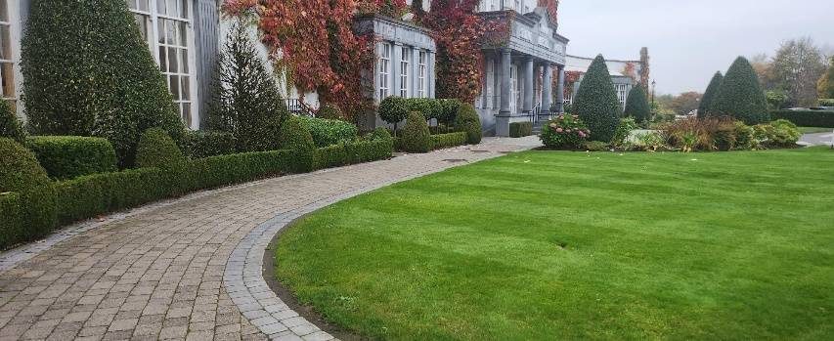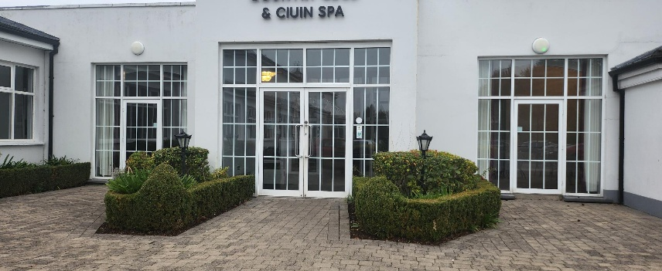

Hotel Layout & Facilities
The hotel is spread across seven floors, with Reception conveniently located on Level 6 upon arrival.
On this level, you will find:
- The Kells Bar
- The Gift Shop
- The Country Club (our leisure centre)
- Conall Cearnach Restaurant
- Setanta Restaurant
- The Games Room
- Conference & Events Spaces
- Guest Bedrooms 601–649
- The Golf Club
Our team at Reception will be happy to guide you to any of these facilities during your stay.

Lift Access
Lifts serving Floors 1–3 are located in the hotel lobby adjacent to the Reception desk.
Lifts to bedrooms on Floors 4–7 are located on Reception Level. Simply follow the bedroom signage and turn right at the Country Club. Our porter team will be happy to guide you and assist with luggage at any time.
Please note that the hotel spans a large area, and some bedrooms are located a distance from Reception.
If walking longer distances may be difficult, we recommend reserving a Deluxe Twin Bedroom, as these are located closest to Reception. We kindly ask that you inform us of any mobility requirements when making your reservation so we can best accommodate your needs.

Bathroom Facilities
- Most Deluxe Rooms, along with all Superior Rooms and Suites feature bathrooms with walk-in shower facilities.
- Classic Rooms include a shower-over-bath combination, which may not be suitable for all guests.

Guests with Visual Impairments
We understand that some guests with visual impairments may prefer a smaller bedroom layout. Please speak with our team about your specific requirements, and we will be pleased to assist in selecting the most suitable room for your stay.

Cranaghan Way Walkway
Cranaghan Way features a smooth tarmacadam pathway. For the most gradual access, we recommend entering the walkway from the Golf Club side, as the pathway near Adventure Golf has a steeper incline.
Please note that some sections of the walkway are hilly. Approaching from the Golf Club side provides the most manageable route. Benches are positioned along the way, offering opportunities to rest and enjoy the surrounding scenery.

Rushen Brook Garden (Secret Garden)
Rushen Brook Garden features brick pathways, allowing guests to comfortably enjoy the outdoor space in all weather conditions. Visitors can relax beneath the canopy of trees and shrubbery or make use of the covered outdoor seating area.

Adventure Golf
Due to the layout and how certain holes are connected, some areas of Adventure Golf are unfortunately not accessible.

Dining & Leisure Accessibility

Our Restaurants
We have three restaurants within the hotel:
- Conall Cearnach Restaurant
- Setanta Restaurant
- Summit Restaurant
Both Conall Cearnach and Setanta Restaurants include some raised seating areas. We kindly ask that you advise us of any accessibility requirements when making your reservation so we can ensure your table is ideally located.
The Summit Restaurant is accessible via the lift in the Club House. The seating layout is open plan, and all areas are fully accessible.

The Country Club
The Country Club provides:
- Accessible shower and toilet facilities
- Low-level lockers for convenience
- Access to the pool deck
Please note that the Sauna, Steam Room, Pool, and Jacuzzi are accessed by steps and may not be suitable for all guests.

The Ciúin Spa
We would be delighted to welcome you to the Ciúin Spa during your stay.
Accessible entry is available from the fifth floor. Please inform a member of our team upon arrival, and they will be happy to guide and assist you throughout your spa experience.
Facilities include:
- Accessible changing rooms and lockers
- Hydrotherapy Suite featuring the Hammam, Steam Room (with slight modifications available upon request), Salt Grotto, and Heated Beds
- Accessible treatment rooms
- Manicure and pedicure station (accessible via a side entrance)
Please note that the Jacuzzi is accessed by steps.
If you have any specific requirements, our spa team will be pleased to discuss how we can best accommodate your needs.

Smoking Area
The covered smoking area at the Country Club entrance is fully accessible for all guests.

Wheelchair Accessible Bedrooms & Bathrooms
We offer specially designed wheelchair accessible bedrooms located on Level 6, closest to Reception, to ensure ease of access.

Room 601
- Bed configuration: Double and Single bed
- All amenities positioned at a lower level for easy reach
- Bathroom equipped with 7 support railings: 3 at the toilet, 2 at the shower, 2 at the wash hand basin
- Toilet transfer side: left-hand side
- Shower seat: mobile shower chair
- Door width (bedroom & bathroom): 830mm
- Emergency pull cord: located in the bathroom

Room 603
- Bed configuration: Double and Single bed
- Amenities at a lower level for easy access
- Bathroom equipped with 5 support railings: 3 at the toilet, 2 at the shower
- Toilet transfer side: right-hand side
- Shower seat: wall-mounted pull-down chair
- Door width (bedroom & bathroom): 830mm
- Emergency pull cord: located in the bathroom

Additional Information
We offer a variety of room types, and our team is happy to help you pre-plan your stay, make modifications where possible, and ensure your visit is comfortable and enjoyable.
To enhance your stay, we also offer:
- Online check-in to avoid queues on arrival
- Room service with delivery charges waived
- Pre-order meals to speed up your dining experience
- Quieter dinner tables and large-font menus
- Support for special dietary requirements
Please speak with a member of our team in advance or on arrival to ensure all your needs are met.

Images of our Accessible bedrooms
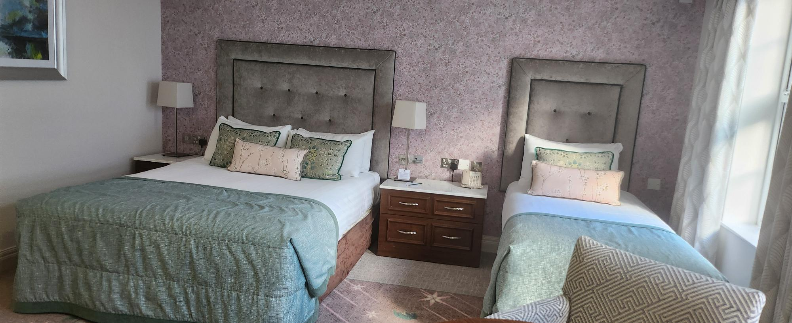

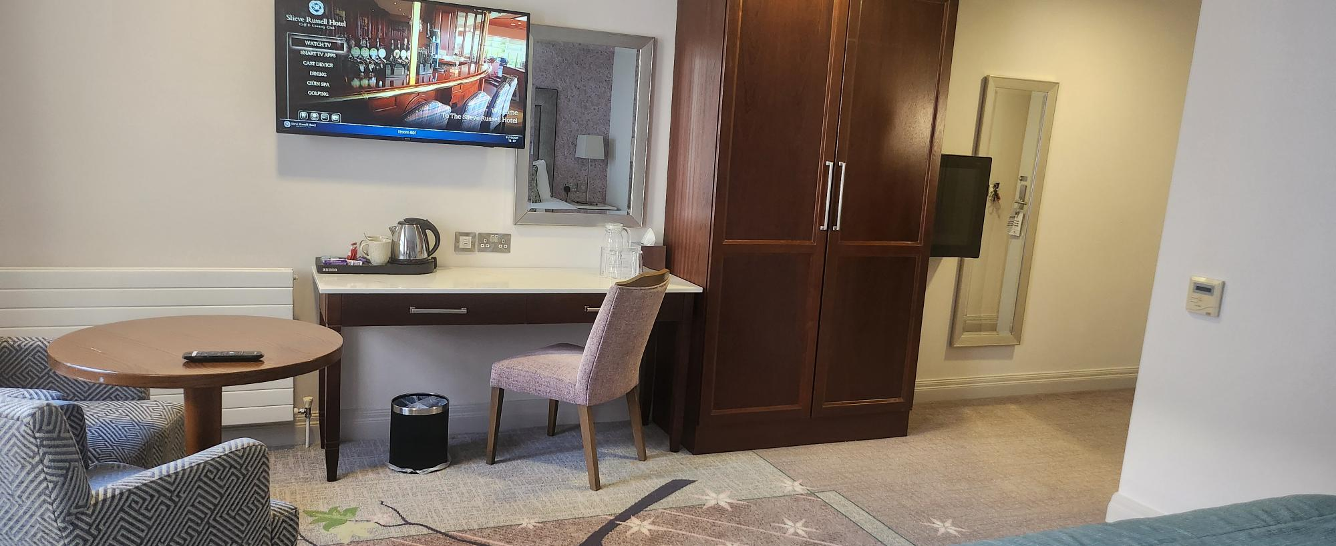

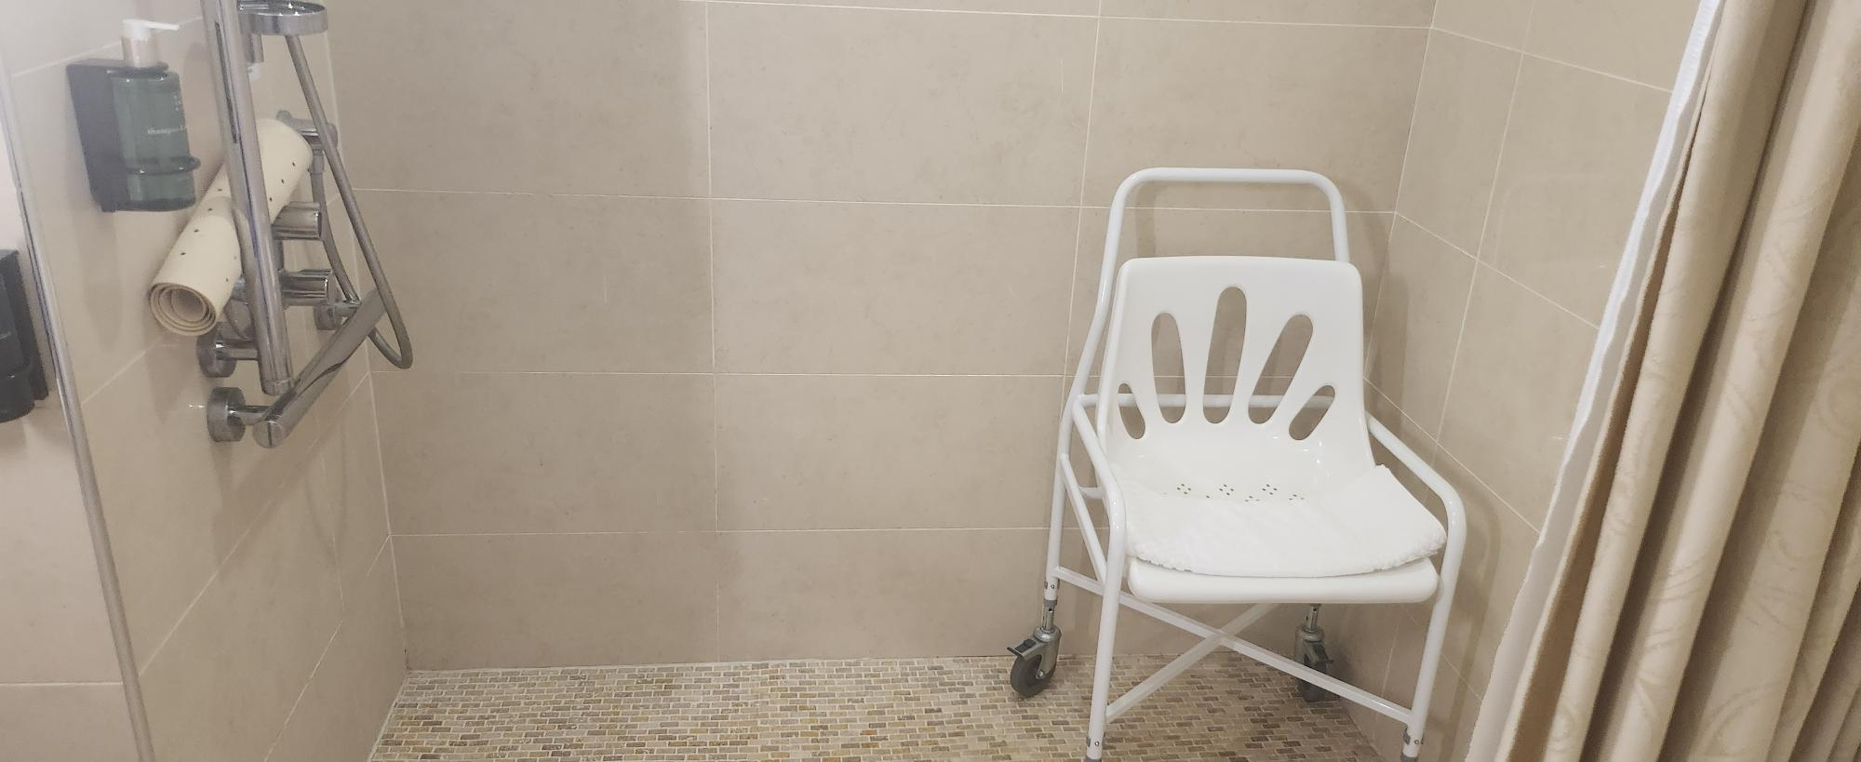
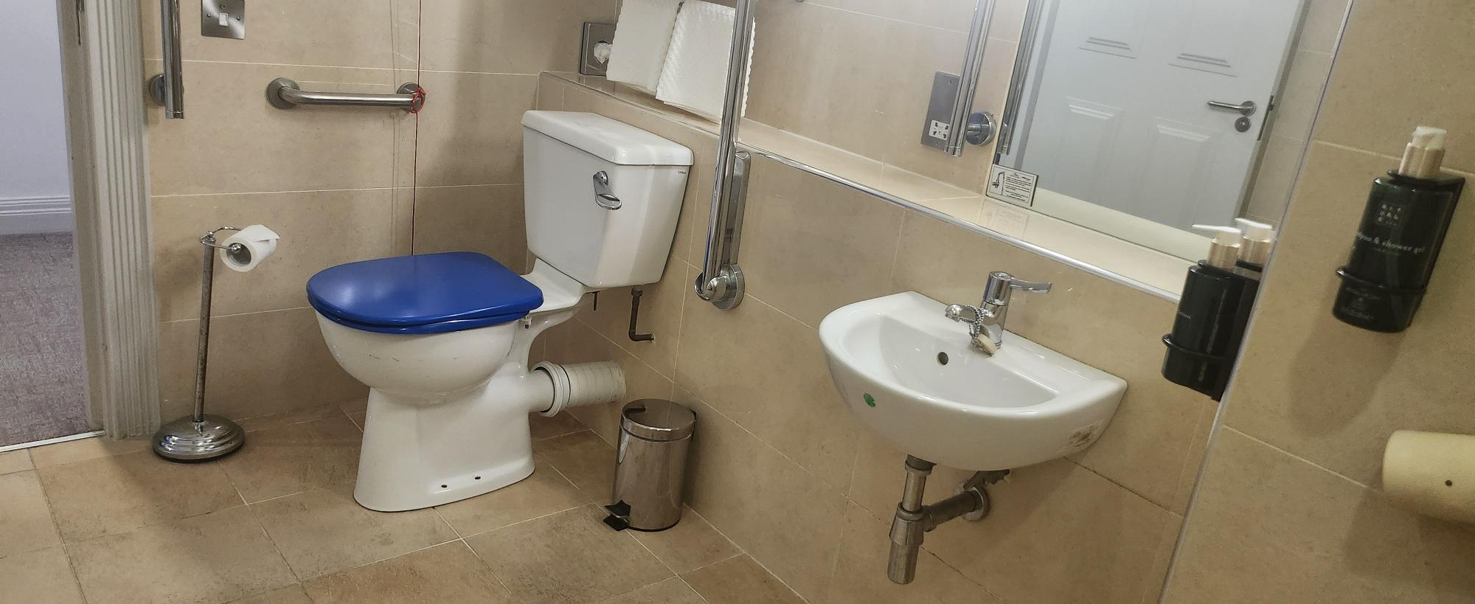
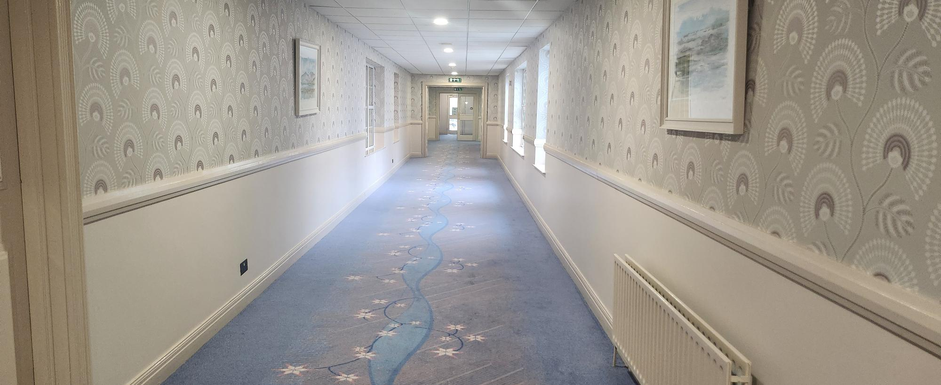

Dementia-Friendly Bedrooms & Bathrooms
Our Dementia-Friendly Bedrooms are located on Level 6, closest to Reception, for convenient access.

Features & Facilities
- Bed configuration: Two king-sized beds with tactile furnishings
- Pictorial signage to support orientation
- Dementia-friendly safety kettle and clock
- Picture books for comfort and engagement
- Night light for safe navigation
- Easy-grip cutlery for mealtimes
- Additional bathroom railings and coloured toilet seat for safety
- Bathrobes provided for ease of use in the leisure club
- Roller blind to cover the bedroom mirror if required
These enhancements are designed to support comfort, safety, and independence for guests living with dementia, ensuring a relaxing and enjoyable stay.

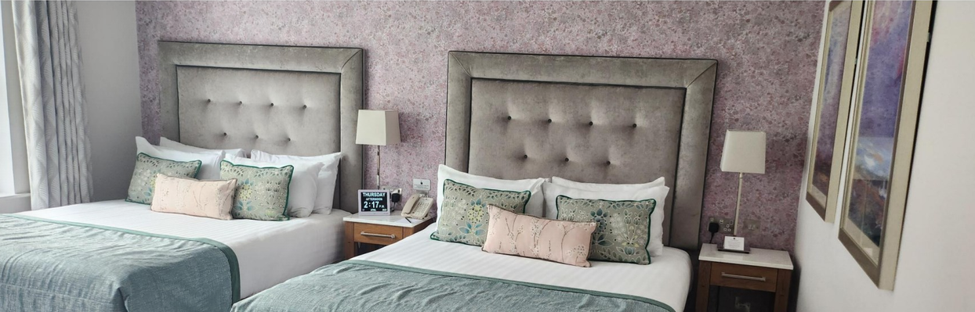
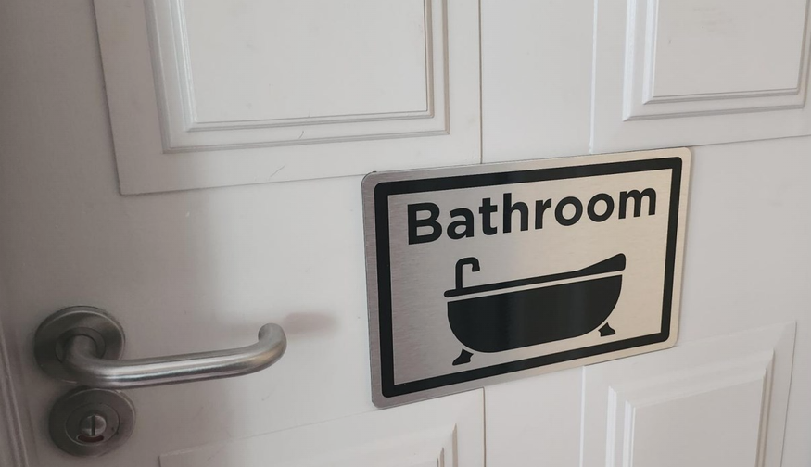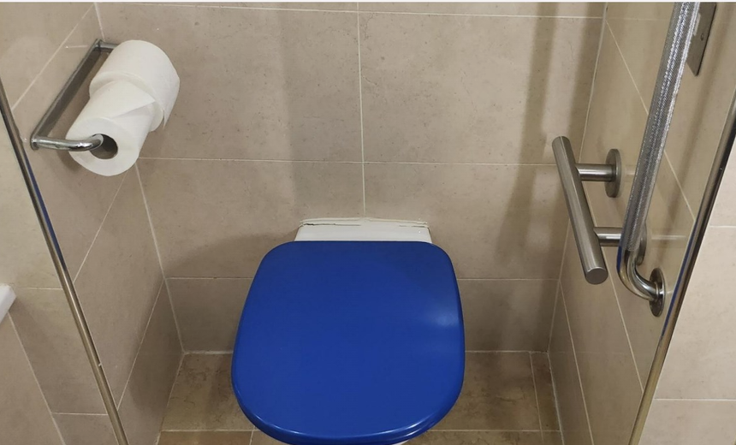
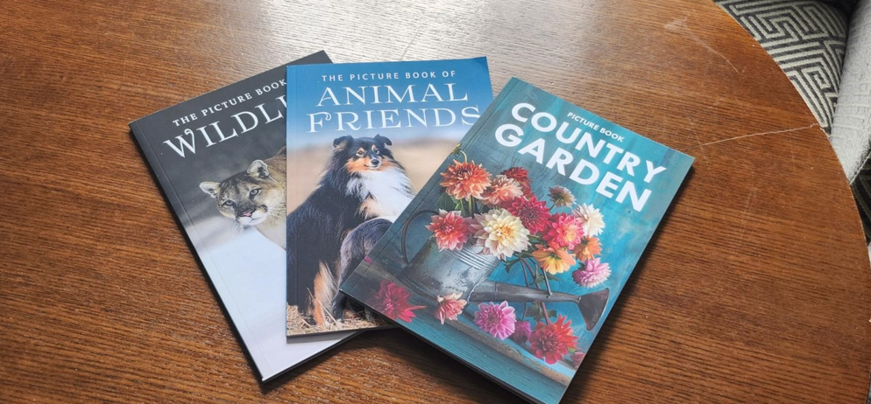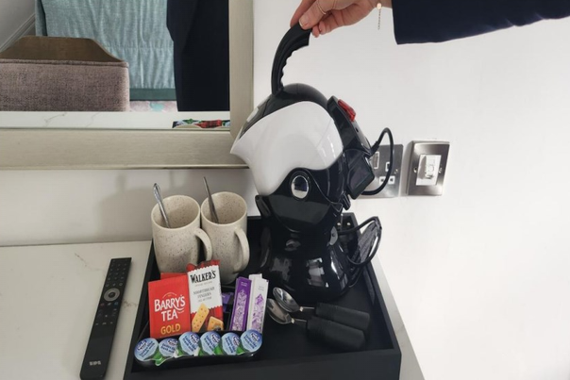

Sensory Story
Our sensory stories are designed to help you or your loved one familiarise yourself with our venue before your visit.

Neurodivergent Friendly Sensory Story
View Online

Dementia Friendly Sensory Story
View Online

Emergency and Medical Information
Nearest Hospital:
Cavan General Hospital – 25 minutes from the hotel
Eircode: H12A5D7
Out-of-Hours Doctor on Call:
NEDOC at Cavan General Hospital – Call 1800 777 911
On-Site Medical Support:
We have first aid trained staff and two defibrillators on site.
For a medical emergency, please call Reception on “0”. Our staff will support you and alert emergency services.
Local Pharmacies:
- Allcare Pharmacy, Main Street, Ballyconnell – +353 49 9526159
- McManus Pharmacy, Main Street, Ballyconnell – +353 49 9526355

Destination Highlights
Slieve Russell is located in Ireland's Hidden Heartlands, offering a perfect base to explore the rich natural beauty, cultural attractions, and unique experiences in the surrounding area. As our guest, we want you to enjoy all the local amenities and destinations that will make you want to return time and time again.

Ballyconnell to Bellaheady, Blue Way Recreational trail.
https://www.slieverussell.ie/attractions/ballyconnell-to-bellaheady-recreational-trail/

Cavan adventure centre
https://cavanadventure.ie/accessibility-welcome-guide/

Share Discover village, Lisnaskea, Co Fermanagh
https://www.sharevillage.org/

Florencecourt House and Gardens, Co Fermanagh.
https://www.nationaltrust.org.uk/visit/northern-ireland/florence-court/accessibility-at-florence-court

The Shed Distillery, Drumshanbo, Co Leitrim
https://www.thesheddistillery.com/accessibility-statement/

Erica’s Fairy Forest, Cootehill, Co Cavan
http://www.ericasfairyforest.com/

Glenview Folk Museum, Ballinamore, Co Leitrim.
https://glenviewmuseum.ie/

Annagh Social Farm, 430 Aughalane Rd, Derrylin, Co Fermanagh. BT92 9BR
E-mail:aghalane@gmail.com Mobile 0044 7771580387 ( pre bookings only)

https://www.facebook.com/p/Annagh-Social-Farm-CIC-100076907007857/

Testimonials

James – July 2025
"Staff are wonderful. Knowledgeable regarding grounds, facilities, and restaurants, and above all, they are approachable and courteous. There are many amazing facilities and restaurants to explore. We shall be returning on many more occasions. One member of our party was using a small electric wheelchair and was very impressed with the disability access to all areas and spaces. Wonderful service. Great disability training given to staff."

Margaret – July 2025
"I am a wheelchair user. I was a bit wary of new surroundings, but I didn't need to worry because everything was perfect. Our room and bathroom really suited our needs. Staff were all so helpful."

William – September 2025
"As usual, we enjoyed our stay. Staff were very helpful with my wife's disability."

Moya – June 2025
"I'm glad to have the opportunity to mention the wonderful service from the lady at reception and the lady at the Summit restaurant. On arrival, she recognised that my husband would have difficulty negotiating the corridors to our booked room type, so upgraded us immediately so that he had less distance to walk to the room. The suite was just fabulous and helped remove the stress associated with a disability. In the restaurant, they made sure my husband's dietary requirements were fully met as well as arranging accessible seating for him. Such a warm and sympathetic experience. We really appreciated the kindness which made for a stress-free dining experience."

Gallery of Images
